**Computing Project Proposal**

**On**

**Blog Application**

**Name: Arju Dutta**

**NCC ID: 00175070**

**Batch: 22 ‘D’**

**Submitted to: Niman Maharjan**

**Level 5 Diploma in Computing**

**Softwarica College of IT and E-Commerce**

**Submitted 9Th April 2019**

Table of Contents

Introduction 1

justification of project 1

Problem statement 1

Description of the project 1

Features 1

Limitation 2

2.2 Aims and Objective. 2

3. development methodology 2

3.1 Methodology used 2

3.2 Design Pattern 3

3.3 System architecture 4

4. Work breakdown structure/Scheduling 5

4.1 Work breakdown Structure 5

4.2 Milestones 6

5. Risk Management 10

6. Configuration management 12

Figure 1:Waterfall model 6

Figure 2:mvc pattern 7

Figure 3:3-tier architecture for blogging application 8

Figure 4:WBS diagram 9

Figure 5: day estimated 12

Figure 6:gantt chart 13

Figure 7:cm config 15

# Introduction

This project is about sharing the view of different individual on the webpage. Todays world is totally based upon information and data which is the most powerful tools in this generation. Technology is changing in our day by day to provide that information of all the articles, latest technology I have designed this web application using php and mysql.

# justification of project

Background of project

Web based blog application is about where you can share the latest information, blog of entrepreneur, business ideas over the internet. We will also provided the upcoming application, their features and many more other data in this in this web based application.

By, registering and login into your personal account you can also share your information over the internet so that other people may also know what is going around the world. Those who input the wrong information the account will get blocked.

User interface is designed very well so end user doesn’t have to find any trouble to use this application. I have used php and mysqli to design this application.

## Problem statement

As you can see many fake information is getting viral nowadays in internet through various social media app. Sometimes conflict is creating through that information which is totally hampering the image of an organization individual and many more.

## Description of the project

### Features

* Update your information
* Can login your personal account
* People can get latest upcoming information
* They can read various article in this webpage
* If someone share wrong information they can get blocked

2. Project scope

Scope

This application is for sharing the information and getting information about what is going on around the world. We register user name, address, verifying their phone number and it will help us to gather the information of individual.

# Limitation

Following are the limitation about the system are:

You can’t share wrong information in the media. In case, if you did so you will be reported in the cybercrime.

## 2.2 Aims and Objective.

The main purpose about this system is to share your opinion, upcoming new gadgets in the market and its suitable and genuine features. Beside this we can also increase the communication skill between the individual by interacting by getting latest information.

The main objectives for this project is to handles all the latest information related to particular events. It helps to protect all the related data and information of the users. It will reduce the paper work because every information is digitalized in our web page. Through this we can even get friendly with the modern world which is all based upon technology.

## 3. development methodology

### 3.1 Methodology used

To design this project, I have chosen waterfall life cycle model which is the old method for developing the software. Although agile is going to take the place of this method because agile is team work. And this project is my single project so I cannot use agile in this system. In this model we can’t skip one step to move to another step. And the main problem with this methodology is if one step got mistake you have to do it from the beginning.

The following steps to use this methodology is

* Requirement and analysis
* Design
* Implementation
* Testing
* Deployment
* Maintenance

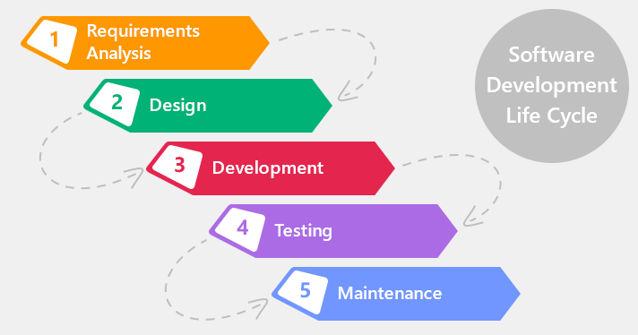

Figure 1:Waterfall model

In the first step, we do the analysis of all the following requirement then in the further step we deal with the design part of the system through the help of documentation we have made in requirement analysis. In designing we design user interface, NLA, use case, Class diagram and analysis specification with the help of this we implement the coding part and design database second lastly we test those function which is black box, white box, integration and unit testing after testing we deploy it to the end user and go with maintenance.

## 3.2 Design Pattern

* I have used MVC pattern which is model view controller
* This is the most useful design pattern
* It separated system functionality

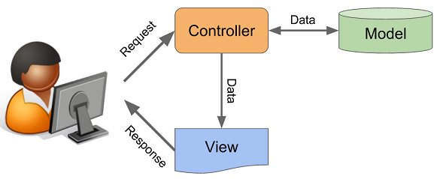

Figure 2:mvc pattern

Model

* Logically related data
* It interacts with database
* Relationship with controller where data is kept
* It depends on framework, sometimes depend on update

View

* This is what we see on screen
* It communicates with controller after our interaction
* It passes the dynamic value

Controller

* React with end user input
* React with user request
* It pulls the data from model
* Send it to the viewer.

## 3.3 System architecture

The can be defined as conceptual model the defines structure, nature and the system which describe the representation of overall system. And for this project I have provide 3-tier.

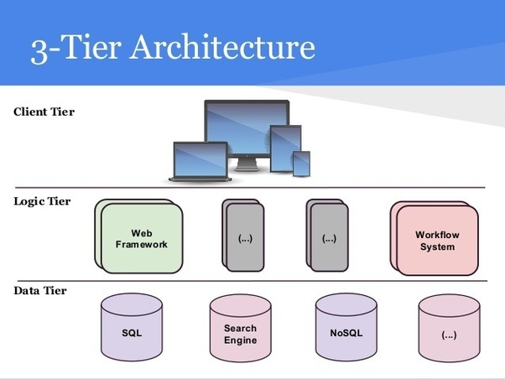

Figure 3:3-tier architecture for blogging application

## 4. Work breakdown structure/Scheduling

### 4.1 Work breakdown Structure

The method of breaking the large project into smaller into is called work breakdown process. Usually manager uses this WBS.

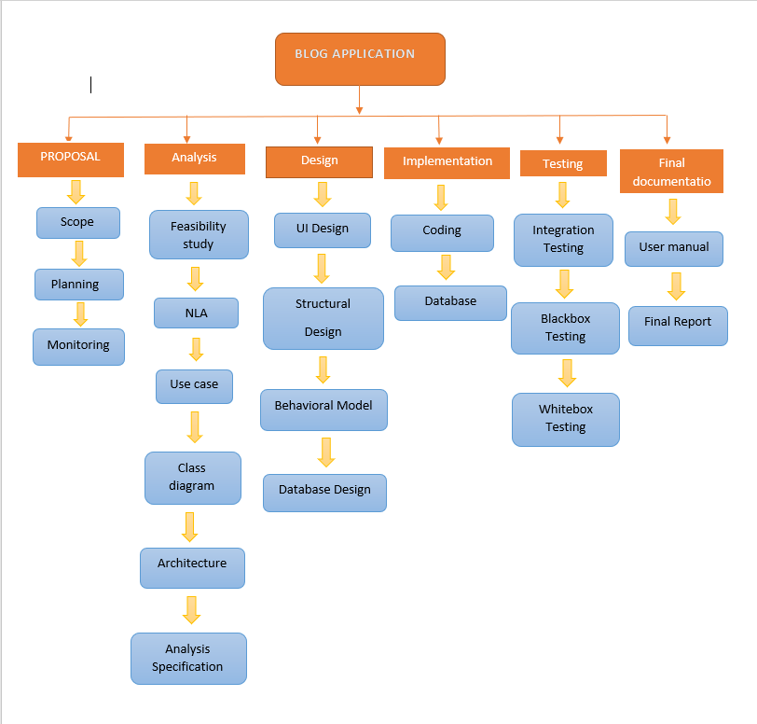

Figure 4:WBS diagram

## 

|  |  |  |
| --- | --- | --- |
| WBS | TASK NAME | NO.of Days |
| 0 | Blog Application | 108 days |
| 1 1.1  1.2  1.3 | Project Management Scope  Planning  Monitoring | 16 5  6  5 |
| 2 2.1  2.2  2.3  2.4  2.5  2.6 | Analysis Feasibility Study  NLA  Use case  Class diagram  Architecture  Analysis specification | 31days 7  4  6  3  4  7 |
| 3 3.1  3.2  3.3  3.4 | Design UI design  Structural Design  Behavioral Model  Database Design | 28days 8  10  3  7 |
| 4 4.1  4.2 | **Implementation**  Coding Database | 22days 6  16 |
| 5 5.1  5.2  5.3  5.4 | **Testing**  Unit Testing  Integration Testing  Blackbox Testing Whitebox Testing | 9days 3  2  3  1 |
| 6 6.1  6.2 | **Deployment**  User Training Final Report | 11days 6  5 |

## 4.2 Milestones

|  |  |
| --- | --- |
| **Milestones** | **Date** |
| **Project Management**  Scope  Planning  Monitoring | 3/25/19 8:00 AM to 3/30/19 5:00 PM  4/1/19 8:00 AM to 4/6/19 5:00 PM  4/5/19 8:00 AM to 4/9/19 5:00 PM |
| **Analysis**  Feasibility Study  NLA  Use Case  Class Diagram  Architecture  Analysis Specification | 4/10/19 8:00 AM to 4/16/19 5:00 PM  4/17/19 8:00 AM to 4/20/19 5:00 PM  4/21/19 8:00 AM to 4/26/19 5:00 PM  4/27/19 8:00 AM to 4/29/19 5:00 PM  4/30/19 8:00 AM to 5/3/19 5:00 PM  5/4/19 8:00 AM to 5/10/19 5:00 PM |
| **Design**  UI Design  Structural Design  Behavioral Model  Database Design | 5/11/19 8:00 AM to 5/18/19 5:00 PM  5/19/19 8:00 AM to 5/28/19 5:00 PM  5/29/19 8:00 AM to 5/31/19 5:00 PM  6/1/19 8:00 AM to 6/7/19 5:00 PM |
| **Implementation**  Coding  Database | 6/8/19 8:00 AM to 6/13/19 5:00 PM  6/14/19 8:00 AM to 6/29/19 5:00 PM |
| **Testing**  Unit Testing  Integration Testing  Blackbox Testing  Whitebox Testing | 6/29/19 5:00 PM to 7/2/19 5:00 PM  7/3/19 8:00 AM to 7/4/19 5:00 PM  7/5/19 8:00 AM to 7/7/19 5:00 PM  7/8/19 8:00 AM to 7/8/19 5:00 PM |
| **Deployment**  User Training  Final Report | 7/9/19 8:00 AM to 7/14/19 5:00 PM  7/15/19 8:00 AM to 7/19/19 5:00 PM |

**Description of Milestones**

**Project Management:**

I allocate total 16 days for this task i.e. is 6 days for Scope, 6 days for Planning, 4 days for Monitoring.

**Analysis**

I allocate total 29 days for this task i.e. 7 days for Feasibility Study, 6 days for Use case diagram, 4 days for Class Diagram, 7 days for Analysis Specification, 4 days for NLA and 4 days for architecture.

**Design**

I allocate total 28 days for this task i.e. 10 days for Structural design, 3 days for Behavioral model, 8 days for UI design, 7 days for database design.

**Implementation**

I allocate total 22 days for this task i.e. 16 days for database build and 6 days for coding.

**Testing**

I allocate total 9 days for this task i.e. 3 days for unit testing 2 days for integration testing, 3 days for black box testing and 1 days for white box testing.

**Deployment**

I allocate total 11 days for this task i.e. 6 days for user manual and 5 days for Final Report.

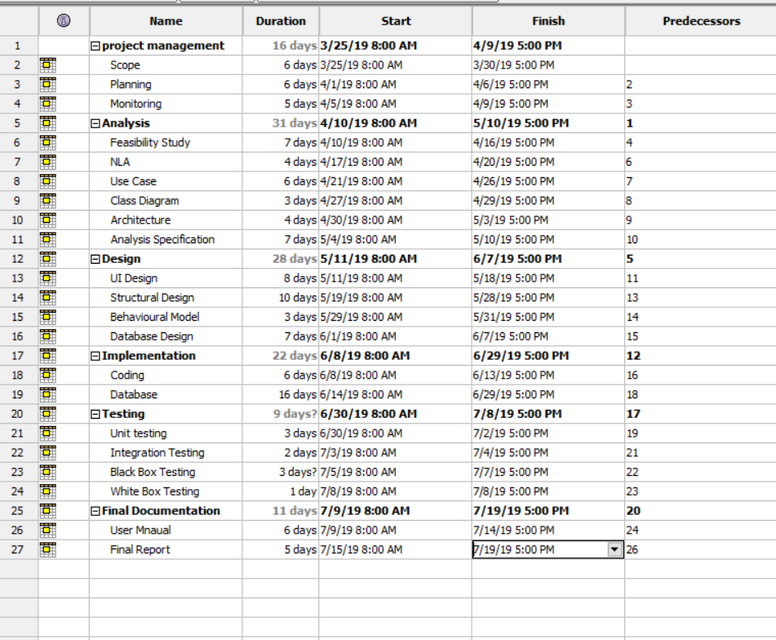

Figure 5: day estimated

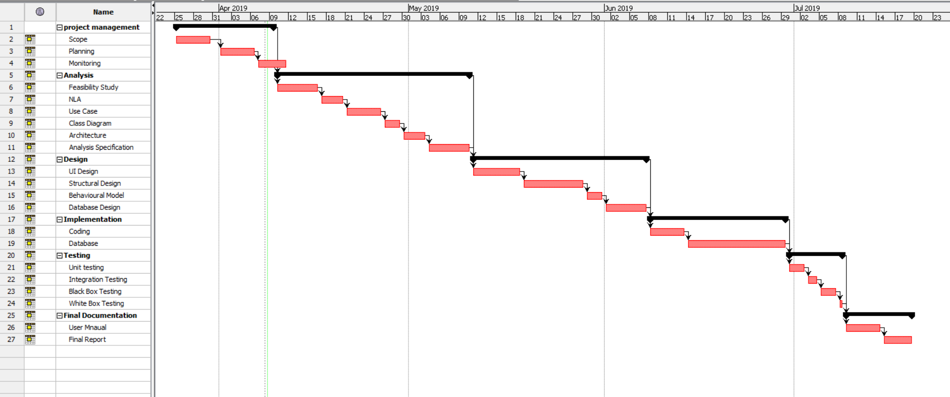

Figure 6:gantt chart

## 5. Risk Management

The way of analyzing the problem that may impact in the project can be known as risk.

There can be many risk while creating this project likewise personal information leakage of the user.

The following are the ways to manage the risk management are:

* Avoidance
* Reduction
* Sharing
* Retention

**Impact = Likelihood * Consequence**

Risk Likelihood values are shown as follows

|  |  |
| --- | --- |
| Likelihood | Value |
| Low | 1 |
| Medium | 2 |
| High | 3 |

* Risk Consequence values are shown below

|  |  |
| --- | --- |
| Consequence | Value |
| Very low | 1+ |
| Low | 1 |
| Medium | 2 |
| High | 3 |
| Very High | 4 |

Risk Consequence values are shown below

|  |  |  |  |  |  |
| --- | --- | --- | --- | --- | --- |
| S. No | Risks | Likelihood | Consequences | Impact | Solution |
| 1 | Poor user interface | 3 | 3 | 4 | User interface should be designed properly. |
| 2 | Data lost | 1 | 3 | 4 | Keep backup of all data |
| 3 | unsatisfied | 2 | 2 | 2 | Meet all the requirement and use easy interface |
| 4 | Server Failure | 2 | 1 | 2 | Server should be maintained in time to time |

# 6. Configuration management

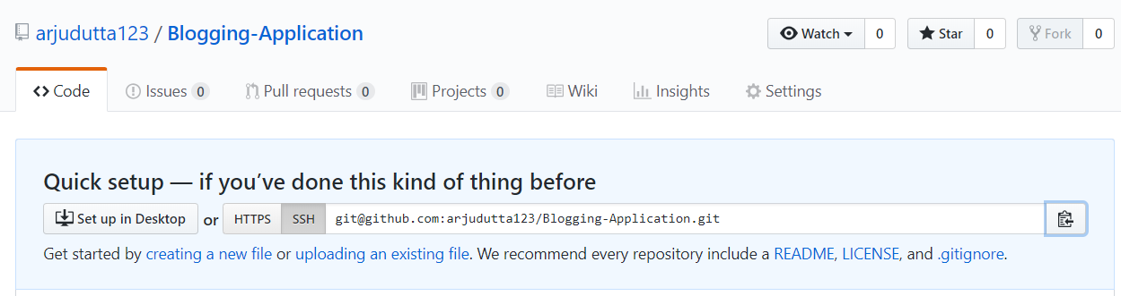

<https://github.com/arjudutta123/Blogging-Application>

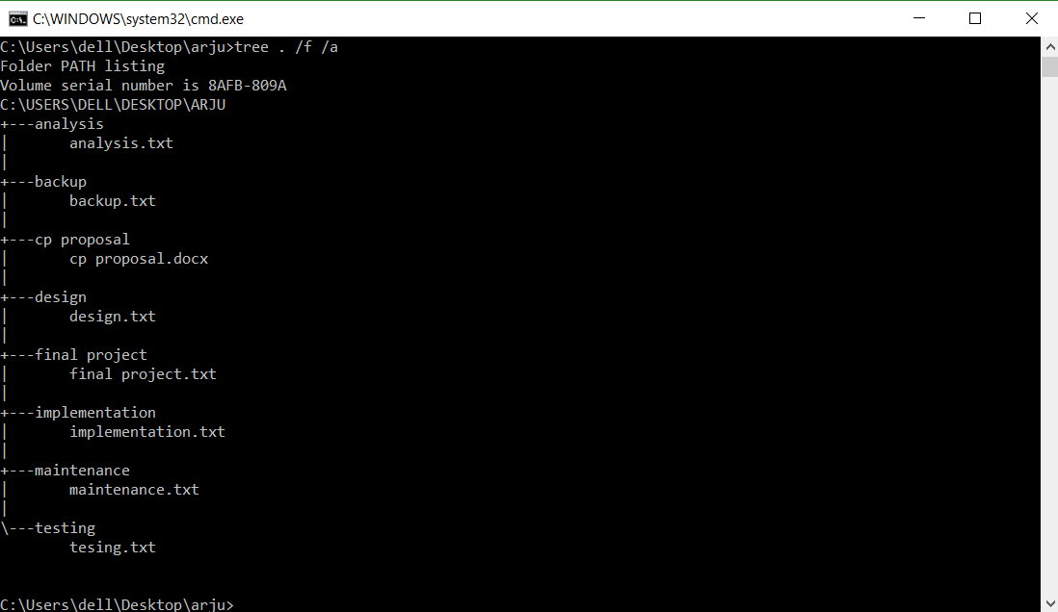

Figure :cm config

## Conclusion

this project is designed for blogging where people can share their point of view in this web application. To make this project I have use waterfall model to make the software which is the older methodology of software industry. To maintain the quality of the software I have also create a Gantt chart to estimate the time that will show the time of product development. Also designed WBS for the manager to divide the work. At most important, I have provide the features that am I going to implement In this application.